**DATS 6102**

**MySQL Environment Setup (macOS)**

**Part I – MySQL Server & MySQL Workbench**

<https://dev.mysql.com/downloads/mysql/>

**Step 1:** Download MySQL Community Server version **8.0.26**

* Navigate to Archives
* Choose appropriate version

**Note:** if you have an issue during download, go with the earlier version of MySQL.



**Step 2:** Install it

**Step 3:**

**Step 4:** Make sure to remember root user password and keep the check **Start MySQL Server once the installation complete**

**Step 5:** Navigate to System Preferences and click on MySQL



**Step 6:** Initialize Database and Start MySQL

**Step 7:** Observe the following directories. We will not be working in these right now

**Step 7:** [Download MySQL Workbench](https://dev.mysql.com/downloads/workbench/) and add connection to localhost

* Click + sign to add connection



**Step 8:** Everything should be left default. Notice that you are running MySQL from localhost (127.0.0.1). Name your connection **DATS 6202** and test it



Close the connection and re-open it. This connection will now be saved, and you can access MySQL anytime.

**Part II – Loading schemas**

**Step 8:** Open **create_databases.sql** in MySQL Workbench via **Open SQL Script** as follows:

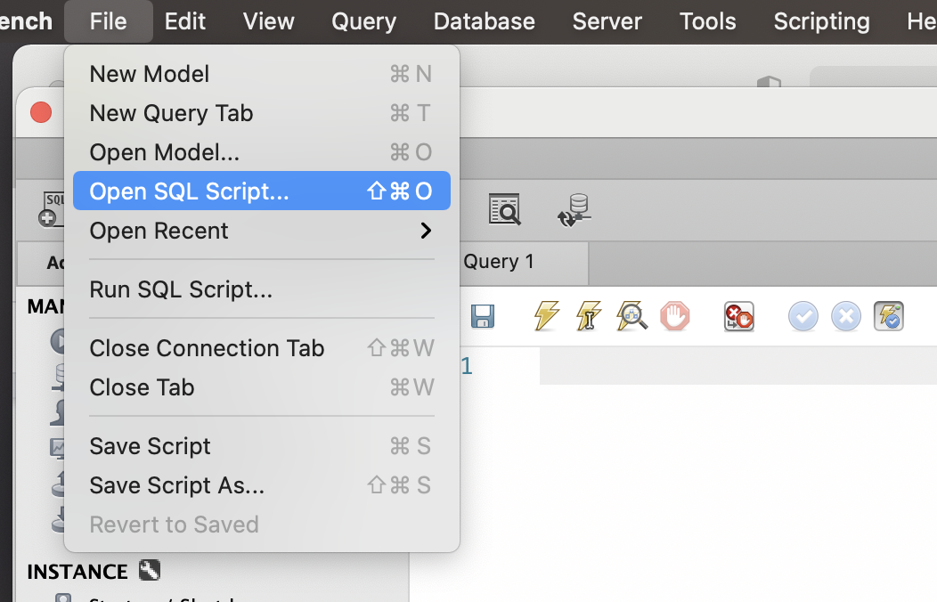

**Step 9**: Click the first lightning button to execute the script

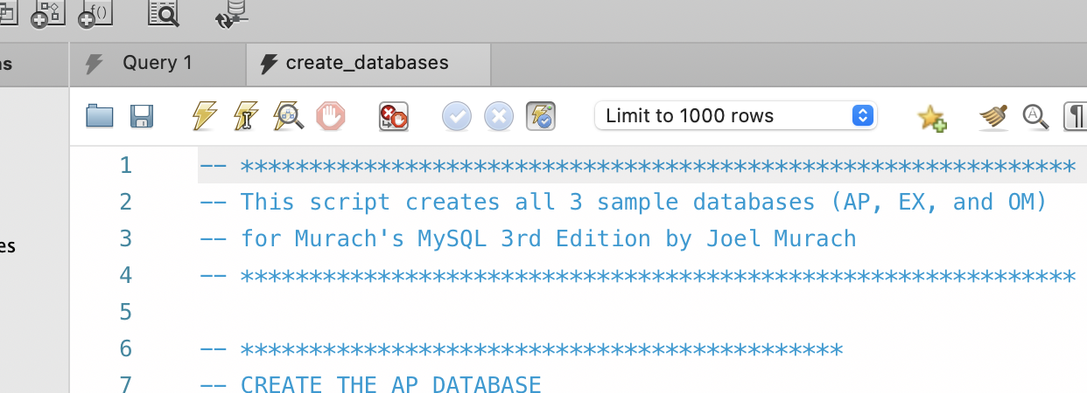

**Step 10:** Click on Schemas → Refresh Button → You shroud now see the following schemas:

